MORNING WORSHIP SERVICE
Oct 1, 2017

Opening “Get All Excited”

Opening Prayer/Announcements

Worship Hymns “Lord, I Lift Your Name on High”
“He Lives” 533
“Because He Lives” 407
“He Hideth My Soul” 340
“You Are My Hiding Place”

Offertory

Special Music
Hurricane Relief

It was voted at the Sept business meeting that the church contribute $5000 to Samaritan’s Purse specifically for the Hurricane Harvey Relief Mission. This particular mission will be ongoing in the weeks and months to come, helping rebuild homes and lives. In addition to this offering we would like to take up a Love Offering on Oct 8 to also contribute to this mission for those feeling led to give.

Also, if there is a specific family or church affected by the hurricanes that anyone knows about that needs assistance, we would consider those needs as well.

Please pray for these offerings.

Sermon Bro. David Atwood

Invitation “Without Him” 300
Join us!
The men will cook an awesome breakfast so we can fellowship before Sunday School
Evening Service - 6:00 PM

NURSERY – available for children age 0 to Kindergarten
Judy Broussard, Shirley Marecle

Hostesses/Hosts for Oct Ushers for Oct
Christine McManus, Cissy Atwood Joe Wilson, Joe Daniel,
Dianne Lindemann David Condron, Hugo Breithaupt

Immediate Need Prayer List
Prayer & Request Information

(Please complete name & address information on reverse side)

❑ I would like to speak with the Pastor.

❑ I would like more information on this church.

❑ I have Prayer Requests or Needs

Date:

Permission to Publicize:
Church Bulletin  Yes  No
Email Prayer Chain  Yes  No

Prayer Request:

Prayer For
Name
Address
Phone

Given By
Name
Address
Phone
Please Contact By

❑ Card  Phone  Visit

Comments

Pray for Mariah Garza. She is seeing a cardiologist for some health issues.

K s b c

Keeping His Word through Sunday School, Bible Study and Church Attendance/Worship

Sunday School Bible Studies for Oct:

Oct 1st Battle Armor Ephesians 6:10-20
Oct 8th Battle Plan Mathew 4:1-10
Oct 15th Caleb: Unwavering Faith Numbers 13:26-30; 14:6-10,21-24
Oct 22nd Solomon: Unfailing Wisdom 1 Kings 3:3-14; 4:29-34 Oct 29th Ruth: All-In Commitment Ruth 1:1-17

9:45 a.m. each Sunday – A place for everyone

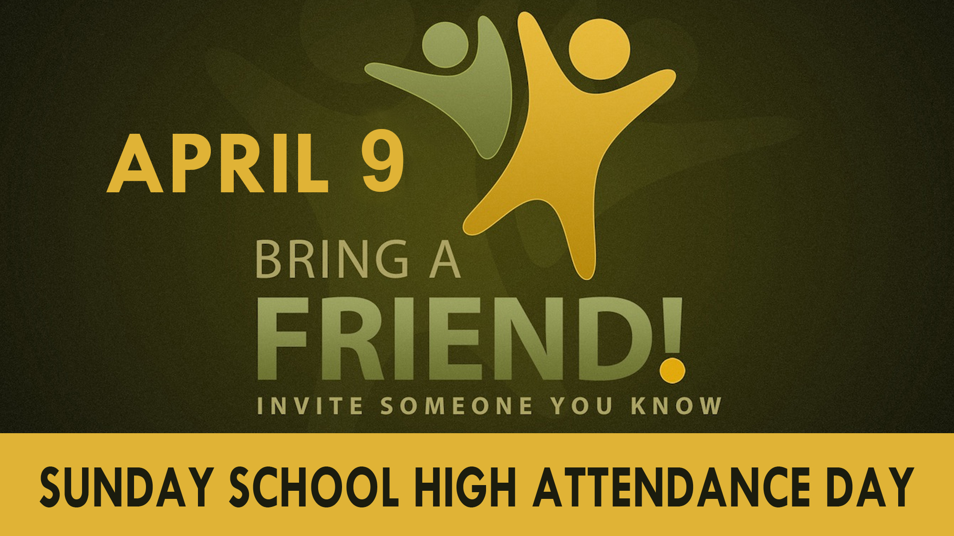
Oct 29

